**Chapter 2  
Fundamental of Ethernet LANs**

* **Router:**

Router basically provides a bridge between outside world (internet) and the inside world (local networks). Moreover, router connects networks to networks.

* **Switch:**

Switches are connection multipliers. They forward the data (packets) to their destination system. There are built-in switches in the routers.

Today, vendors combine routers and switches and there are 3 or 4 switches on the router.

* **Access Points (AP):**

These are used for wireless connection as the switch is connected via a LAN cable to AP. The AP send the relevant packets to the wireless device.

Today, we have wireless routers that perform all of the above functionality.

“**How internet via fiber optics work?**”

Fiber-optic cabling contains long thin strands of fiberglass. The attached Ethernet nodes send light over the glass fiber in the cable, encoding the bits as changes in the light.

**UTP Cable and RJ45 connector:**

The standard Ethernet cable with an 8-pinned connecter at the ends.



**Straight Through Cable:**

Standard cables (10BASE-T and 100BASE-T) uses 2 pairs of wires in a UTP cable. The pins in the switch and NIC are made so that they can act as receiver and transmitter alternatively. The 2 pair of wires are on the pin 1,2 and 3,6 at both end. So, the NIC transmitter uses wires at pin 1,2 and the switch receiver uses wires at pin 1,2. Similarly, NIC receiver uses wires at pin 3,6 and the switch transmitter uses wires at pin 3,6. I know that’s hard to take, thus a figure is attached:



But sometimes, there is the case when the user might want to connect 2 PCs or 2 Switches. As mentioned earlier, the built-in hardware pins are made alternatively for a PC and a Switch.

Therefore, for the problem of having two similar devices and both ends can be solved by a **Crossover cable.**

**Crossover Cable:**

There are two ends to a Straight Through Cable, so too connect two similar devices, we change the one pair of the cable at **an** end. In simpler words, one end has receiver at 1,2 and transmitter at 3,6 and the other end has receiver at 3,6 and transmitter at 1,2. See the figure:

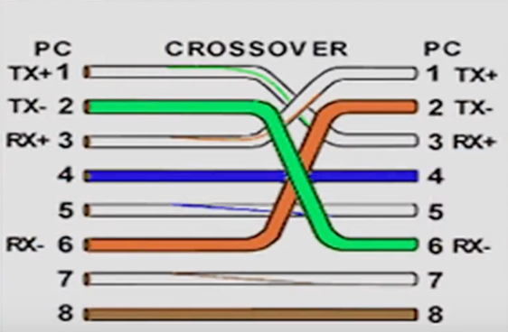

We can see that the wire at one end is connected to 1,2 pinouts at one end and 3,6 at the other end.

Configuration in the devices are given in the table:



See the example:



**Ethernet Frame:**

It contains an Ethernet header at the front, the encapsulated data in the middle and Ethernet trailer at the end.



The short description of each of the upper mentioned terms is:

Preamble: Synchronization

Start Frame Delimiter (SFD): Signifies that the next byte begins the Destination MAC Address field.

Destination MAC Address: Identifies the intended recipient of this frame.

Source MAC Address: Identifies the sender of this frame.

Type: Defines the type of protocol listed inside the frame; today, most likely identifies IP version 4 (IPv4) or IP version 6 (IPv6).

Data and Pad: Holds data from a higher layer, typically an L3PDU (usually an IPv4 or IPv6 packet). The sender adds padding to meet the minimum length requirement for this field (46 bytes).

Frame Check Sequence (FCS): Provides a method for the receiving MC to determine whether the frame experienced transmission errors.

**Mac-address:**

The first half of mac address is OUI assigned by the IEEE to organizations/manufacturers. The other half is assigned by the manufacturer given that the combination remains unique universally.

**Group Address:**

1. **Broadcast address:** Address has the value of FF:FF:FF:FF:FF:FF or (we can say FFFF:FFFF:FFFF), which means all devices in the network can access the frame.
2. **Multicast address:** These addresses are used when the frame is need to send to a group of hosts within a network.

**Type (EtherType):** This field defines what network layer protocol are we using (ipv4 or ipv6). For Ipv4, type = 0800 and for ipv6 type = 08DD

**Frame Check Sequence (FCS):** This is at the sole field at the trailer of the frame and it is used for error detection within the frame that might have occurred due to electrical issue or due to a bad NIC. FCS just detects the error and does not resolve the error as well. TCP detects and resolve error as well. Error detection is carried out by solving a complex math problem at the sender’s end and the result is stored in the FCS field to crosscheck whether the result calculated at the receiver end is same or not. A mismatch depicts an error and the frame stands discarded.

**Full Duplex vs Half Duplex:**

When two devices are connected together using a network cable, if both devices could send and receive data at the same instance of time, then it will be full duplex. In half duplex, one of the two devices would have to wait for its turn. LAN hubs uses half duplex but currently they are obsolete and we only have full duplex practical now and the LAN switches are common nowadays as they implement full duplex. An example of Full Duplex is telephone network where both of the person can talk simultaneously. Full duplex takes extra bandwidth as it can process more data.

LAN hubs are considered to be layer 1 devices only. As the data can be send in the single direction only, so the receiver should be a single device. Same goes for sender, as signal coming from more than 1 device at a time result in collision.



This problem can be solved by using LAN switches that are 2 layered devices and the switch can confirm the sender’s and/or receiver’s mac address from the data link layer. But if both incoming frames need to be forwarded to a single target user at a given instance of time, the switch will queue one of the frames.